SIMATS ENGINEERING (SAVEETHA SCHOOL OF ENGINEERING)
Department of Computer Science and Engineering

ASSESSMENT TOOL 2– Code Debugging Questions
Course Code: | CSA0303 | Course Title: | Data Structures
CO Assessed: | CO2 | Assessment: | Assessment Tool 2 – Debugging and Optimization Questions
Weightage: | 10% of CIA | Total Marks: | 100
CO2 Statement: | ADT array, Operations on arrays, Searching Algorithms, Linear Search, Binary Search, Suffix Arrays & LCP Arrays ADT, Linked List, Stack, Queue, Applications.
Student Name: | M.NANDHINI | Reg. No.: | 192472318
Section / Batch: | SLOT-C | Date: | 30-07-26

Code of Conduct
I ____M.NANDHINI(192472318)_________ (Name / Reg No) certify that this submission is my original work and that I have adhered to the guidelines specified for this assessment. I understand that any violation of academic integrity rules will result in disciplinary action.
Signature of the Student: _____M.NANDHINI____________________

Instructions
- This test contains 50 MCQ Based Questions, each carries 2 marks. Total: 100 Marks.
- When a student answer using a analytical problem, in evaluation the answer should contain following four requirements: Understanding of concepts, Connections between ideas, Logical structure, Clarity of representation.
- No negative marking. Unanswered questions carry zero marks.
- Electronic Gadgets are not permitted in the class. Take it as test and submit in the class.

Section / Topic | Focus | Q Nos | Marks
Stack | Linear | 10 | 30
Queue | Enq, Deque | 10 | 40
Linked List | Applications of linked list | 10 | 40
GRAND TOTAL: |  | 100 Marks

Annexure A – Code Debugging Questions
**>> Enclosed

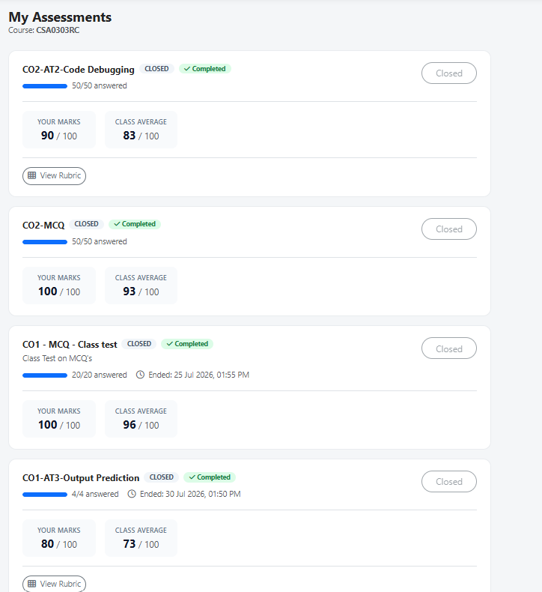

Rubrics for Calculation
Criteria | Weightage | Level 4 – Exemplary | Level 3 – Proficient | Level 2 – Developing | Level 1 – Beginning
Understanding of Problem Context | 20 | Clearly understands the problem and accurately identifies all requirements | Good understanding with minor gaps | Basic understanding; some requirements unclear | Poor understanding or misinterpretation of the problem
Application of Concepts | 30 | Accurately applies appropriate concepts to solve complex problems | Applies relevant concepts correctly with minor errors | Applies basic concepts with limited accuracy | Fails to apply appropriate concepts
Problem-Solving Approach | 20 | Logical, well-structured, and efficient approach | Mostly logical approach with minor gaps | Basic approach with some inconsistencies | Illogical or unclear approach
Accuracy of Solution | 20 | Completely correct solution with proper justification | Mostly correct with minor errors | Partially correct solution | Incorrect or incomplete solution
Clarity | 10 | Clear, well-organized, and properly explained solution | Understandable with minor clarity issues | Limited clarity and explanation | Poorly presented and difficult to understand
Faculty In-charge | Course Coordinator | Program Director
Signature: _______________ | Signature: _______________ | Signature: _______________
Date: ___________________ | Date: ___________________ | Date: ___________________

